# Introduction.

PV system is widely applied into our daily as an important source of renewable energy. However, the efficiency of the system is not always at its best due to many problems. One of that is due to electrical problems such as open circuit, short circuit, arc. Environment also can affect to the system such as partial shading and damaged due to the obstacle that hit the panel of scratch on the surface during installation process. To understand more about the behavior of fault and a sensor system is developed with digital signal processing to filter and extract the character of the fault for fault detection purpose.

In this project, a low pass filter and FFT method is used for extract important data from collected sample of the system. Then the frequency and filtered data is applied to 3 method: threshold based method, statistic method to detect the fault.

# Theory

## Fast fourier transform

## Moving average filter

The moving average is the most common filter in DSP, mainly because it is the easiest digital filter to understand and use. In spite of its simplicity, the moving average filter is optimal for a common task: reducing random noise while retaining a sharp step response. This makes it the premier filter for time domain encoded signals. However, the moving average is the worst filter for frequency domain encoded signals, with little ability to separate one band of frequencies from another.

There are many version of this moving average filter such as moving average filter include the Gaussian, Blackman, and multiple pass moving average. These have slightly better performance in the frequency domain, at the expense of increased computation time. However, in this project, for its simple, I will only use the moving average filter and multiple-pass moving average filters.

As the name implies, the moving average filter operates by averaging a number of points from the input signal to produce each point in the output signal. In equation form, this is written:

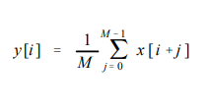

Where

* x [ ] is the input signal,
* y [ ] is the output signal, and
* M is the number of points in the average.

For example, in a 5 point moving average filter, point 80 in the output signal is given by:

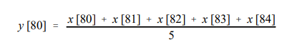

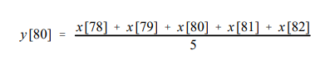

the moving average filter is a convolution of the input signal with a rectangular pulse having an area of one.

Extra additional:

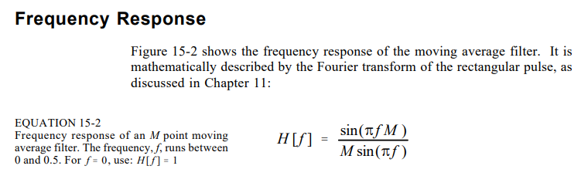

Multiple-pass moving average filters involve passing the input signal through a moving average filter two or more times. Figure 15-3a shows the overall filter kernel resulting from one, two and four passes. Two passes are equivalent to using a triangular filter kernel (a rectangular filter kernel convolved with itself). After four or more passes, the equivalent filter kernel looks like a Gaussian (recall the Central Limit Theorem). As shown in (b), multiple passes produce an "s" shaped step response, as compared to the straight line of the single pass. The frequency responses in (c) and (d) are given by Eq. 15-2 multiplied by itself for each pass. That is, each time domain convolution results in a multiplication of the frequency spectra.

## Low-pass filter

About the low pass filter, I will use the digital low pass filter, cause my samples is sampled with 1000 Hz ( why casue I am measuring the dc value which don’t have frequency and if it have its will also for less than 200 Hz due to noise and AC voltage as 54Hz.

## PV system basic knowledge

### PV arrays

### MPPT

### Kind of fault in PV array and detection technique

# Matlab code

## FFT and low pass filter

## Fault detection technique

# Conclusion

# Reference